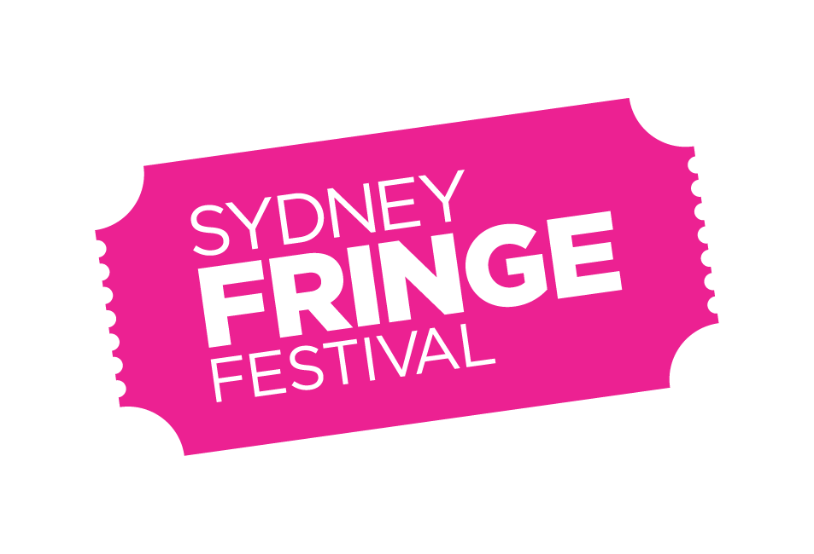
POSITION DESCRIPTION

POSITION: Access Coordinator
LOCATION: 303 Marrickville Road, Marrickville, NSW 2204 (phsyically accessible offices)
REPORTS TO: Sydney Fringe Business Manager
WORKS WITH: The Sydney Fringe Programming Team
The Sydney Fringe Festival Management Team
REMUNERATION: $65,000 per annum, plus Superannuation (pro-rata)
STATUS: Part Time (2 days per week)
EMPLOYEE BENEFITS: 6 weeks annual leave (pro-rata) following successful completion of probation period; Employee Assistance Program; Professional Development training; flexible/hybrid working arrangements.
KEY AREAS: The Access Coordinator is responsible for the development and implementation of The Sydney Fringe’s accessibility initiatives for artists and audiences, including the development and implementation of the Disability and Inclusion Access Plan.

Background

The Sydney Fringe Inc. (formerly Newtown Entertainment Precinct Association (NEPA)) is a cultural industries organisation and advocacy group for the live arts and music sectors. NEPA established The Sydney Fringe Festival in 2010. The Sydney Fringe Festival www.sydneyfringe.com has received widespread industry support and engagement from the artistic community. In 2022, nearly 2,000 artists were featured in 550 works across all disciplines across 84 venues. 175 artists with disability participated and the festival included 30 events that focused on issues of disability. Over 50% of the festival venues were accessible and 74 events provided accessible performances including Auslan interpreted, Audio Described and relaxed performances.

Assisting artists is at the forefront of everything we do. The Fringe offers a professional platform from which emerging, early-career and professional artists can promote their work to new audiences. The Fringe strives to ensure that all artists have a wonderful Fringe experience. We believe that Sydney's independent artists are what make this city so great, and as such we are dedicated to promoting the independent sector to Sydney's mainstream audiences.

The Sydney Fringe team goes to extreme lengths to ensure that audiences, artists and venues have a successful festival experience; this is the essence of what makes the Sydney Fringe so unique and is essential to the success of our festival.

Role Description
The Access Coordinator position was created in 2020 as a new role within The Sydney Fringe. The role was created to address the barriers that people who identify as disabled, chronically ill and/or d/Deaf face when accessing the services of The Sydney Fringe, with a particular focus on access for Artists and Audiences.

The Access Coordinator is responsible for the development and implementation of The Sydney Fringe’s Accessibility initiatives for artists and audiences, including the development and implementation of the Disability & Inclusion Access Plan.

The Access Coordinator works closely with all Festival and Programs staff, and in liaison with the Access Advisory Panel, to ensure that all festival program and events are as accessible as possible (including physical access, access language provision, other access requirement provision).

The position also has responsibility for shows that have an access service attached, including community outreach and consultation and the development and implementation of programs securing, highlighting and ensuring accessibility at performances by and about artists who identify as disabled, chronically ill and/or d/Deaf.

In 2022, the Access Coordinator was primarily responsible for the creation and delivery of “Limitless”, a two week micro-festival that celebrated artists who identified as disabled, chronically ill and/or d/Deaf at a dedicated hub at 107 Projects Redfern. Limitless offered an inclusive and accessible space for audiences and artists alike featuring Auslan, relaxed performances and audio described gallery tours.

This position has the possibility for flexible working arrangements, and reasonable adjustments can be made to the workspace to accommodate access requirements.

Key Responsibilities and Duties
Audience Accessibility:
- Regularly consult with the Access Advisory Panel (4 meetings per annum) and, where appropriate, broader d/Deaf and disabled community, around all elements of accessibility.
- Periodically update the Disability & Inclusion Access Plan (current document is 2021-2023).
- Lead the implementation of the Disability & Inclusion Access Plan.
- Work with the Operations Manager to provide the greatest possible accessibility at all festival events and venues.
- Work with venues to make meaningful improvements in their physical accessibility.
- Gather and collate accessibility information from all venues and events for dissemination to audiences (e.g. through the website Venue Accessibility Table).
- Work with artists and producers (including on registered events and Sydney Fringe produced events) to encourage and facilitate the provision of access services and other access requirements at festival events.
- Work with the marketing team to ensure that the Festival website and all marketing and promotional material is accessible.
- Work with the Marketing & Communications Manager and Ticketing Manager to ensure the festival ticketing system is accessible.

Artist Accessibility:
- Work with the Programming Team to ensure Festival registration platform is accessible.
- Work with the Programming Team to support the ongoing delivery of Limitless, a micro-festival for artists who identify as disabled, chronically ill and/or d/Deaf.
- Conduct outreach to d/Deaf and disabled community to identify barriers to participation, develop strategies for removing those barriers, and encourage participation.
- Work with artists who identify as disabled, chronically ill and/or d/Deaf to ensure that their access requirements are met at all stages of the presenting process.
- With the Programs Producer, Partnerships Manager and Philanthropy Manager, seek opportunities for collaboration, funding and partnership that provide support and opportunities for artists who identify as disabled, chronically ill and/or d/Deaf.

Data Collection and Reporting:
- With the Programs Coordinator and Production Coordinator, gathering and analysis of access related data including access provisions, % of accessible events, number of participating artists who identify as disabled, chronically ill and/or d/Deaf.

Other:
- Periodically provide recommendations to Management regarding access.
- Be an advocate for access, and the rights of people who identify as disabled, chronically ill and/or d/Deaf within the organisation.
- As required, act as a public spokesperson for the festival in relation to accessibility, access & inclusion related programs, the rights of people who identify as disabled, chronically ill and/or d/Deaf and other projects as appropriate.
- Maintain an awareness of other barriers to entry that intersect with access requirements (economic disadvantage, cultural and language barriers etc.)

Key Skills and Knowledge

- In depth knowledge of the barriers faced by people who identify as disabled, chronically ill and/or d/Deaf;
- Knowledge of and experience facilitating physical access provision, the provision of access services (e.g. Auslan, audio dexription, captioning, relaxed performances) and other access requirements;
- Ability to relate to artists and venues in a friendly and professional manner;
- Expertise in the needs of Venues, Artists and Producers, particularly those who identify as disabled, chronically ill and/or d/Deaf;
- Understanding of festival cycles and the ability to provide access support to key stakeholders at different stages of the cycle;
- Skills and experience communicating with people who identify as disabled, chronically ill and/or d/Deaf;
- Strong problem solving and negotiation skills, with a solutions-based approach;
- Ability to communicate and develop relationships with a broad range of people, both internal and external to the organisation, in a professional and ethical manner;
- Attention to detail and accuracy;
- Ability to work in a small integrated team as well as the ability to work autonomously;
- Strong planning and time management skills, with a proactive approach to managing competing tasks and priorities and work to deadlines;
- Technically proficient with computers, software systems and IT generally;
- Ability to maintain effective shared folder systems, files and procedural documents;
- Enthusiasm and a positive attitude, together with an ability to be a team player;
- Values consistent with the goals and philosophy of The Sydney Fringe.

Selection Criteria

- In this role lived experience of disability and/or D/deafness will be a valuable asset;
- At least two years relevant experience in Arts Administration, cultural events, festivals or similar;
- Demonstrated experience working with Artists, particularly artists who identify as disabled, chronically ill and/or d/Deaf, to produce Arts projects;
- Prior experience in access provision for arts and cultural events;
- Demonstrated experience in cultivating positive relationships and working with Venues and Artists to create mutual value;
- A contact base within d/Deaf and/or disabled community.

External Relationships

- Venues
- Artists and Producers
- d/Deaf and disabled community
- Audiences

Internal Relationships

- Business Manager (direct report)
- Festival Director/CEO
- Programming Team
- Access Advisory Panel
- Marketing & Communications Manager
- Operations Manager
- Production Coordinator
- Access Advisory Panel

How to Apply

Applications should respond to the Position Description, and selection criteria and include:
- A covering letter addressing the selection criteria and current CV (no more than 4 pages total)
OR
- A video or audio recording of up to 10 minutes long addressing the selection criteria, your experience/background and why you would be a good fit for the role.

Applications should be emailed to hq@sydneyfringe.com by 5pm on Friday 24 February 2023. Please ensure that the subject of the email reads as “Access Coordinator application: name of applicant”.

Written applications should be a PDF or Word document with your name and the position title as the document’s name. For large video or audio files please provide a Dropbox, Google Drive or similar link to the file.

Should you have any further questions regarding this position, or seek to submit your application by a different method more accessible to you, please contact the Sydney Fringe Festival Business Manager, Zoe Davies: hq@sydneyfringe.com or call 02 7813 4527.

Diversity and Opportunity
Sydney Fringe provides equal access to all applicants for positions without regard to race, color, religion, gender, sexual orientation, gender identity, national origin, age, disability, genetic information or marital status.
On the principal of ‘Nothing About Us Without Us’, a team member with lived experience of disability or a D/deaf team member is being actively sought for this role.

