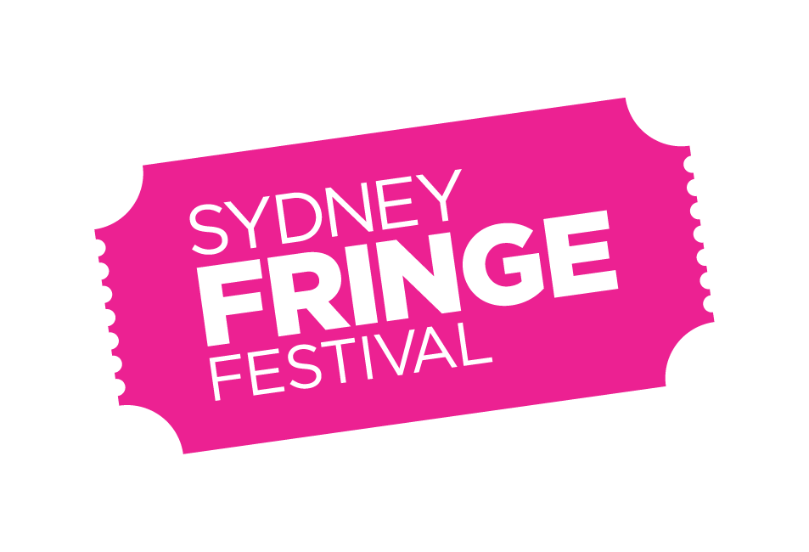

**POSITION DESCRIPTION**

POSITION: Designer

LOCATION: 303 Marrickville Road, Marrickville, NSW 2204

REPORTS TO: Marketing & Communications Manager

WORKS WITH: The Sydney Fringe Management Team

REMUNERATION: $75,000 pro rata, plus Superannuation.

STATUS: Fixed Term Employee (or Contractor*)

KEY AREAS: The Designer is responsible for the translation of creative concepts into effective visual designs for a range of marketing collateral, online campaigns and print based projects.

TERM: The position is scheduled as a full time role based predominantly in the Sydney Fringe office from 1 May-7 October 2023.

An additional 30 hours work beyond the contract will be required to deliver the End of Year report design in November 2023.**

* Experienced Design contractors are encouraged to apply for this role and some flexibility (to manage existing clients) will be considered subject to predominant availability during the Term for Sydney Fringe.

** The hours are a guide and are subject to change.

**Background**

The Sydney Fringe Incorporated is a cultural industries organisation and advocacy group for the live arts and music sectors. The Sydney Fringe Festival was established in 2010 (www.sydneyfringe.com) and has received widespread industry support and engagement from the artistic community. In 2022, following two years of cancellation due to the Covid-19 pandemic, 2181 artists were featured in 525 events across all disciplines in 84 venues.

Assisting artists is at the forefront of everything we do. The Fringe offers a professional platform from which emerging, early career and professional artists can promote their work to new audiences. The Fringe strives to ensure that all artists have a positive Fringe experience. We believe that Sydney's independent artists are what make this city so great, and as such we are dedicated to promoting the independent sector to Sydney's mainstream audiences.

To create a terrific Fringe experience for artists it is vital that care is also taken to maintain venue relationships and strive for audience satisfaction. The Sydney Fringe team goes to extreme lengths to ensure that audiences, artists, and venues have a successful festival experience; this is the essence of what makes the Sydney Fringe so unique and is essential to the success of our festival.

**Our Values**

Expression; Access; Connection; Integrity; Excellence

**Role Description**

Working closely with the Marketing & Communications Manager and Festival Director/CEO, the Designer will be responsible for all design for the Fringe Festival as a brand, print collateral, and festival marketing. Including translation and extension of concepts into effective visual designs for a range of marketing assets, online campaigns, large-scale out of home design, and print projects.

**Key Responsibilities and Duties:**

* You will work directly in collaboration with the Marketing & Communications Manager and be able to work collaboratively to take a project from concept to completion.
* Finished artwork for a broad range of creatives – print & digital – including, but not limited to:
  + Core Hero imagery: i.e editing shoot, deep etching photos, using Adobe suite to finesse images.
  + Festival Guide: design and build the festival guide.
  + Flyers, posters, street banners, outdoor media, street furniture.
  + Assist on partner collateral where necessary.
  + Create all social media content, including stills and some film assets. Size according to channel.
  + Create Venue signage, directional, informative and marketing.
  + Oversea the creation of handbooks for venues, artists, marketing and reports.
  + Coordinate the creation of different-sized digital media - banners, online advertising, and imagery.
  + Aid in the design file upkeep, utilizing Fringe naming and filing conventions.
  + Website graphics
  + Event invites
  + Merchandise including T-shirts and passes
  + Formatting of festival reports, and administration tools such as business cards, letterheads etc.

**Key Skills and Knowledge**

* Experienced Mac user
* Demonstrated high level of experience using Adobe Creative Suite (minimum Photoshop / Illustrator / InDesign);
* Understanding of Premiere Pro or After Effects (desirable but not necessary);
* Skills in video editing;
* Skills in creating content for socials;
* Ability to effectively understand and interpret a design brief;
* Ability to advise the Sydney Fringe team on design strategies and current trends, to reach the Sydney Fringe audience;
* Ability to follow instructions/briefs, whilst also taking initiative, showing good judgement, and manage own projects;
* Strong design eye and attention to detail and accuracy, with all deliverables of a high quality and professional standard;
* Demonstrated understanding of marketing material and its creation;
* Ability to work effectively in a fast-paced environment;
* Strong problem-solving skills, with a solutions-based approach;
* Ability to communicate in a professional manner;
* Ability to work in a small integrated team as well as the ability to work autonomously;
* Exceptional interpersonal and verbal communication skills;
* Strong planning and time management skills, with a proactive approach to managing competing tasks and priorities and work to deadlines;
* Ability to maintain effective shared folder systems, files and procedural documents;
* Enthusiasm and a positive attitude, together with an ability to be a team player;
* Values consistent with the goals and philosophy of The Sydney Fringe;

**Qualifications and Previous Experience**

* Completed at least 3 years’ experience across a variety of graphic design projects and branded collateral, both print and digital, within an agency or in-house role.
* Demonstrated ability to follow complex, multi-deliverable briefs from concept to completion;
* Design qualification

**How to Apply**

Applications should respond to the position description, and address the selection criteria and include:

* A covering letter and current CV (no more than 3 pages)
* The names and contact details of two referees
* Portfolio demonstrating relevant experience

Applications should be submitted as a PDF document with your name and the position title as the document’s name, and emailed to [hq@sydneyfringe.com](mailto:hq@sydneyfringe.com) - please ensure that the subject of the email reads as “Designer Application: name of applicant”.

**Deadline for applications: Friday 14 April 2023, 5pm.**

Due to the high volume of expected applications, only shortlisted applicants will be contacted personally.

Should you have any further questions regarding this position please contact the Sydney Fringe Marketing & Communications Manager, Sarah Findlay, on [Sarah@sydneyfringe.com](mailto:Sarah@sydneyfringe.com)

**Diversity and Opportunity**

Sydney Fringe provides equal access to all applicants for positions without regard to race, colour, religion, gender, sexual orientation, gender identity, national origin, age, disability, genetic information or marital status.

**ANNEXURE A**

**2019 Sydney Fringe Designer Scope of Works and Schedule**

The Designer is responsible for producing all collateral required by the Sydney Fringe team including but not limited to:

* Core Hero imagery
* Festival Printed Guide
* Flyers, DL’s, posters, street banners, Large outdoor media
* Venue signage
* Corretly sized Digital media - banners, advertising and imagery
* Website graphics
* Event invites
* Merchandise including T-shirts and passes
* Formatting of festival reports, handbooks and administration tools such as business cards, letterheads

The below Schedule incorporates the estimated times for the contract deliverables. These are subject to change.

|  |  |
| --- | --- |
| DUE DATE | * DELIVERABLE / TASK |
| 15 APRIL | * Finalise logo lockup |
| 15 MAY | * Primary look and feel of festival collateral. * Festival Guide cover * Street Banners * Airport banners |
| 31 MAY | * Digital graphics (website, social and advertising) * Artist’s logo strips and other relevant elements * Social Frames for internal and external use. |
| 15 JUNE (Major collateral) | * Pop up and temporary outdoor signage (Partnership requests. * Poster suite (generic and venue specific) * Bus, other transport-specific signage * Large-scale outdoor skins (venue, flags, hoarding billboard artwork, Rock Posters) |
| 30 JUNE | * Opening night Invites * Hero Social Media release. * Social content for first release of main events, designed to fit all social specs. * Physical Collatoral: Passes, Lanyards, t’shirts, Media Wall. |
| 1 JUNE – 15 JULY | * Festival Guide * Social Media advertising designed for Meta, Tik Tok and google ads. |
| JULY – AUGUST (EVENT SPECIFIC COLLATERAL) | * Event-specific collateral (e.g. Fringe KIDS, Fringe Ignite, hubs) * Venue specific collateral * Further Digital assets to support the campaign * Digital content creation. * Reel/ Tik Tok Creation. * All partner collateral designed. |
| 1 SEPTEMBER | * Award Winner Laurels * Award Winner Artist Frames. |
| 1 OCTOBER | * End of Year Festival Report. |
| 15 OCT | * 2024 Artist Registration Collateral * End of festival graphics for website * Business cards and email signatures * Donation Campaign Graphics. * End of year reports |
| 15 DECEMBER | * Any additional requirements |