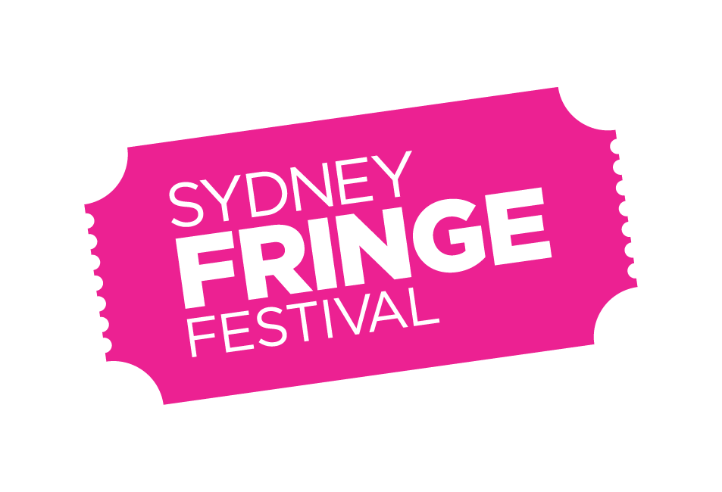
POSITION DESCRIPTION

POSITION: Sydney Fringe Programs Co-Ordinator
LOCATION: 303 Marrickville Road, Marrickville
REPORTS TO: Sydney Fringe Programs Manager
REMUNERATION: $65,000 per annum, plus Superannuation (pro rata)
STATUS: Full time, fixed Term (Start date asap to 14 October 2023)
KEY AREAS: The Programs Co-Ordinator is primarily responsible for artist and venue liaison and administration of the festival Open Access program, as it relates to artists, producers, and venue managers. Working with the Programs Manager, they are also responsible for artist and venue liaison and administration related to Sydney Fringe produced in-festival programs.

Background

The Sydney Fringe Incorporated is a cultural industries organisation and advocacy group for the live arts and music sectors. The Sydney Fringe Festival was established in 2010 (www.sydneyfringe.com) and has received widespread industry support and engagement from the artistic community. In 2022, following two years of cancellation due to the Covid-19 pandemic, 2181 artists were featured in 525 events across all disciplines in 84 venues.

Assisting artists is at the forefront of everything we do. The Fringe offers a professional platform from which emerging, early career and professional artists can promote their work to new audiences. The Fringe strives to ensure that all artists have a positive Fringe experience. We believe that Sydney's independent artists are what make this city so great, and as such we are dedicated to promoting the independent sector to Sydney's mainstream audiences.

To create a terrific Fringe experience for artists it is vital that care is also taken to maintain venue relationships and strive for audience satisfaction. The Sydney Fringe team goes to extreme lengths to ensure that audiences, artists, and venues have a successful festival experience; this is the essence of what makes the Sydney Fringe so unique and is essential to the success of our festival.

Our Values

Expression; Access; Connection; Integrity; Excellence

Role Description
The Programs Co-Ordinator is primarily responsible for artists and venue liaison and administration of the festival Open Access program, as it relates to artists, producers, and venue managers. The Programs Co-Ordinator is the primary point of contact for artists, producers and venue managers in the festival Open Access program and is responsible for managing all correspondence and documentation relating to these relationships.

Working closely with the Programs Manager, the Programs Coordinator will also support any artist and venue liaison and administration related to Sydney Fringe produced programs including Artist Development (pre-festival Producer Masterclasses, in-festival Professional Development program, Artist Awards), year-round Artist programs (e.g., Fringe HQ) and Partner activations during the festival that include Open Access artists.

Key Responsibilities and Duties
Registration and Programming:

- Administer the end-to-end artist registration process.
- Initiate and maintain contact with all registered artists, to determine venue needs and to identify any events that need specialised support.
- Manage all correspondence from artists and guide them through the festival cycle and process specific to Sydney Fringe.
- Maintain ongoing records for and manage the receipt of all registration fees.
- With the Programs Manager, source venues for unique events that require non-traditional or site-specific space.
- With the Programs Manager, work to venue match all relevant festival events.
- In collaboration with the Programs Manager, work to curate genre specific Managed Venue/Fringe Hubs as directed.
- With the Programs Manager, maintain the functionality of the artist registration system and complete all required “backend work” to ensure operation and smooth functionality.
- Collect and document all artists’ operational needs, and work with the Operations Manager to ensure their reasonable provision.
- Deliver to artists Venue Information Packs, provided by the Operations Manager.
- With the Programs Manager, liaise with Managed Venue/Fringe Hub artists to ensure that any issues and/or requirements that may affect artists and producers in these venues are communicated and managed.
- With the Programs Manager, ensure all artist contracts and agreements are in place prior to production.
- With the Programs Manager and Operations Manager, ensure that artists in Managed Venues/Fringe Hubs comply with Public Liability, Risk Assessment, and other insurance obligations, ensuring collection and filing of this data.

Marketing and Ticketing:

- With the Programs Manager, collate all material required to build the festival guide and ticketing e.g., session times, imagery, and event copy.
- Collate the content of the ‘show’ pages across all the marketing platforms, including the printed guide, website, and ticketing system.
- Deliver the show pages in the Festival Guide. Ensure agreed timelines are met, and materials are ready to be extracted for design.

Data Collection and Reporting:
- In collaboration with the Programs Manager, gather all artist data for use during the festival and post-festival reporting processes. Data includes:
  - Artist details for Settlement
  - Door sales from Artists
  - Attendance rates from Non-ticketed Events
  - Artist Demographic Data
  - Event data (sessions)

Other:

- With the Programs Manager and the Ticketing Manager, work to facilitate the creation and roll-out of Artist Passes.
- Work to the Festival Timeline and key deliverable dates set out by the Programs Manager.
- Attend Festival events and functions as required.
- Other reasonable duties as directed by the Programs Manager and Sydney Fringe management.

Key Skills and Knowledge

- Ability to relate to artists, producers, and venue managers in a friendly and professional manner.
- Ability to work within a small team as well as the ability to work autonomously and contribute creatively.
- Expertise in the needs of Artists and Producer requirements, and the ability to schedule and program within the organisation’s requirements.
- Ability to multi-task and manage large workload and volume of enquiries.
- Knowledge of festival cycles and the ability to provide support to artists at different stages of the cycles.
- Ability to maintain and execute effective project timelines.
- High emotional intelligence.
- Strong negotiation and problem-solving skills, with a solutions-based approach.
- Ability to communicate and develop relationships with a broad range of people, both internal and external to the organisation, in a professional and ethical manner.
- Attention to detail and accuracy.
- Ability to work in a small integrated team as well as the ability to work autonomously.
- Exceptional interpersonal and verbal communication skills.
- Strong planning and time management skills, with a proactive approach to managing competing tasks and priorities and work to deadlines.
- Technically proficient with computers, software systems and IT generally.
- Ability to maintain effective shared folder systems, files, and procedural documents.
- Enthusiasm and a positive attitude, together with an ability to be a team player.
- Willingness to work flexible hours for effective festival delivery.
- Values consistent with the goals and philosophy of The Sydney Fringe.

Qualifications and Previous experience

- At least 3 years relevant experience in arts administration, cultural events, festivals or similar.
- Demonstrated experience working with artists and venues to produce arts projects.
- Demonstrated experience in cultivating positive relationships and working with artists to create mutual value.
- Demonstrated background in working in arts/culture and/or entertainment/events sector.
- Detailed understanding of the Independent Arts sector in Sydney.

External Relationships

- Artists and Producers
- Venue partners

How to Apply

Applications should respond to the position description, and address the selection criteria and include:
- A covering letter and current CV (no more than 3 pages)
- The names and contact details of two referees

Applications should be submitted as a PDF document with your name and the position title as the document’s name, and emailed to hq@sydneyfringe.com - please ensure that the subject of the email reads as “Programs Coordinator Application: name of applicant”.

Deadline for applications: Friday 7 April 2023, 5pm.
Please note, only shortlisted applicants will be contacted personally.

Should you have any further questions regarding this position please contact Sydney Fringe on hq@sydneyfringe.com

Diversity and Opportunity
Sydney Fringe provides equal access to all applicants for positions without regard to race, colour, religion, gender, sexual orientation, gender identity, national origin, age, disability, genetic information, or marital status.

