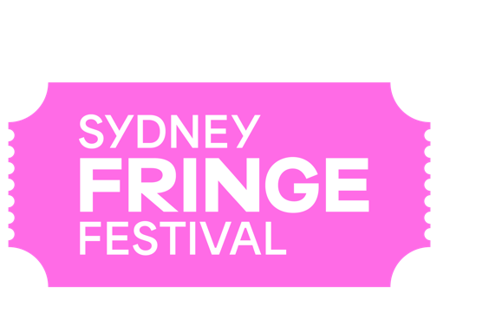
POSITION DESCRIPTION
POSITION: Designer
LOCATION: 303 Marrickville Road, Marrickville, NSW 2204
REPORTS TO: Head of Marketing
REMUNERATION: $75,000 pro rata, plus Superannuation.
STATUS: Fixed Term Employee (or Contractor*)
KEY AREAS: The 2024 Sydney Fringe Festival campaign creative has been designed by an external agency partner. The in-house Sydney Fringe Designer is responsible for the roll out of this campaign into effective visual designs for a range of marketing collateral, online campaigns and print based projects.
TERM: The position is scheduled as a full time role based in the Sydney Fringe office starting asap, ideally from 15 April- 5 October 2024.
An additional 30 hours work beyond the contract will be required to deliver the End of Year report design in November 2024.**
* Design contractors are encouraged to apply for this role and some flexibility will be considered subject to predominant availability during the term and ability to be based at the Sydney Fringe office .
** The hours are a guide and are subject to change.

Background
The Sydney Fringe Incorporated is a cultural industries organisation and advocacy group for the live arts and music sectors. The Sydney Fringe Festival was established in 2010 (www.sydneyfringe.com) and has received widespread industry support and engagement from the artistic community. In 2023, 2181 artists were featured in 400 events across all disciplines in 80 venues. Close to 100,000 people attended the event that generated over $34 million in economic impact.

Assisting artists is at the forefront of everything we do. Sydney Fringe offers a professional platform from which emerging, early career and professional artists can promote their work to new audiences. The Sydney Fringe strives to ensure that all artists have a positive Fringe experience. We believe that Sydney's independent artists are what make this city so great, and as such we are dedicated to promoting the independent sector to Sydney's mainstream audiences.

The Sydney Fringe team goes to great lengths to ensure that audiences, artists, and venues have a successful festival experience; this is the essence of what makes the Sydney Fringe so unique and is essential to the success of our festival.

Our Values
Expression; Access; Connection; Integrity; Excellence

Role Description
Working closely with the Head of Marketing, the Designer will be responsible for all design for the Fringe Festival as a brand, print collateral, and festival marketing. Including translation and extension of concepts into effective visual designs for a range of marketing assets, online campaigns, large-scale out of home design, and print projects.

Key Responsibilities and Duties:
- You will work directly in collaboration with the Head of Marketing and be able to work collaboratively to take a project from concept to completion.
- Finished artwork for a broad range of creatives – print & digital – including, but not limited to:
  - Festival Guide: design and build the festival guide
  - Flyers, posters, street banners, outdoor media, street furniture
  - Partner activation collateral
  - Paid and organic social media content, including stills and some film assets. Size according to channel
  - Create Venue signage, directional, informative and marketing
  - Oversea the creation of handbooks for venues, artists, marketing and reports
  - Create full suites of digital assets including programmatic and display banners.
  - Aid in the design file upkeep, utilizing Fringe naming and filing conventions.
  - Website graphics
  - Event invites
  - Merchandise including T-shirts and passes
  - Formatting of festival reports, and administration tools such as email signatures

Key Skills and Knowledge
- Experienced Mac user;
- Demonstrated strong level of experience using Adobe Creative Suite (minimum Photoshop / Illustrator / InDesign);
- Understanding of Premiere Pro or After Effects (desirable but not necessary);
- Skills in video editing;
- Skills in creating content for socials;
- Ability to effectively understand and interpret a design brief;
- Ability to advise the Sydney Fringe team on design strategies and current trends, to reach the Sydney Fringe audience;
- Ability to follow instructions/briefs, whilst also taking initiative, showing good judgement, and manage own projects;
- Strong design eye and attention to detail and accuracy, with all deliverables of a high quality and professional standard;
- Demonstrated understanding of marketing material and its creation;
- Ability to work effectively in a fast-paced environment;
- Strong problem-solving skills, with a solutions-based approach;
- Ability to communicate in a professional manner;
- Ability to work in a small integrated team as well as the ability to work autonomously;
- Exceptional interpersonal and verbal communication skills;
- Strong planning and time management skills, with a proactive approach to managing competing tasks and priorities and work to deadlines;
- Ability to maintain effective shared folder systems, files and procedural documents;
- Enthusiasm and a positive attitude, together with an ability to be a team player;
- Values consistent with the goals and philosophy of The Sydney Fringe.

Qualifications and Previous Experience
- At least 2 years’ experience across a variety of graphic design projects and branded collateral, both print and digital, within an agency or in-house role.
- Demonstrated ability to follow complex, multi-deliverable briefs from concept to completion;
- Design qualification.

Diversity and Opportunity
Sydney Fringe provides equal access to all applicants for positions without regard to race, colour, religion, gender, sexual orientation, gender identity, national origin, age, disability, genetic information or marital status.

How to Apply
Applications should respond to the position description, and address the selection criteria and include:
- A covering letter and current CV (no more than 3 pages)
- The names and contact details of two referees
- Portfolio demonstrating relevant experience

Applications should be submitted as a PDF document with your name and the position title as the document’s name, and emailed to hq@sydneyfringe.com - please ensure that the subject of the email reads as “Designer Application: name of applicant”.
Deadline for applications: Monday 8 April 2024, 5pm.
Due to the high volume of expected applications, only shortlisted applicants will be contacted personally.
Should you have any further questions regarding this position please contact Zoe Davies, Business Manager, on hq@sydneyfringe.com.
Sydney Fringe is an equal opportunity employer and encourages candidates from diverse backgrounds to apply. Our organisation is committed to creating an inclusive and supportive work environment that values diversity and promotes equal opportunities.

