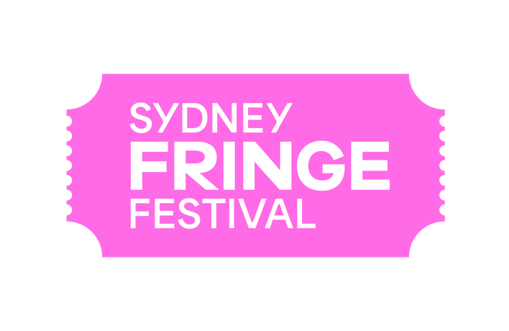

POSITION DESCRIPTION

Title: Ticketing Manager
Reports to: Business Manager
Works with: Programs and Operations team
Marketing team
Festival casual staff and volunteers
Status: Fixed term full time contract:
29 April 2024 - 1 November 2024

The Sydney Fringe working hours are 9am-5pm Monday-Friday. The hours for this role will vary during the Festival period (during event activation) with evening and weekend hours required.

Remuneration: $80,000 per annum plus super pro rata

Location: Marrickville, NSW

Background

The Sydney Fringe Incorporated is a cultural industries organisation and advocacy group for the live arts and music sectors. The Sydney Fringe Festival was established in 2010 (www.sydneyfringe.com) and has received widespread industry support and engagement from the artistic community. In 2023, 2181 artists were featured in 400 events across all disciplines in 80 venues. Close to 100,000 people attended the event that generated over $34 million in economic impact.

Assisting artists is at the forefront of everything we do. Sydney Fringe offers a professional platform from which emerging, early career and professional artists can promote their work to new audiences. The Sydney Fringe strives to ensure that all artists have a positive Fringe experience. We believe that Sydney's independent artists are what make this city so great, and as such we are dedicated to promoting the independent sector to Sydney's mainstream audiences.

The Sydney Fringe team goes to great lengths to ensure that audiences, artists, and venues have a successful festival experience; this is the essence of what makes the Sydney Fringe so unique and is essential to the success of our festival.

Our Vision
To be celebrated as one of the world’s leading Fringe Festivals.

Our Purpose
To champion the independent cultural sector, placing it at the heart of Sydney.

Our Values
Expression; Access; Connection; Integrity; Excellence

Role description

Reporting to the Business Manager and working closely with the Programs, Operations and Marketing teams, the Sydney Fringe Ticketing Manager will be responsible for the following:
- Management of all aspects of ticket sales and box office operations including ticketing build management, on-site box office activations and the Ticketing Coordinator(s);
- Ensuring that all required documentation is maintained, and that the processes and policies of the Sydney Fringe are adhered to;
- Liaising, with utmost professionalism and as a Sydney Fringe ambassador, with external stakeholders, event presenters and project partners on external events for which Sydney Fringe manages the ticketing.

Key Responsibilities
- Building the events in the Sydney Fringe Ticketing system in an efficient and timely manner to meet on-sale schedule;
- Ensuring the smooth sale and delivery of all Sydney Fringe Festival tickets through effective Ticketing and Box Office operations;
- Responding to Ticketing enquiries and complaints from the general public and Sydney Fringe Festival artists/presenters and ensure they are dealt with in an efficient, professional, accurate and timely manner;
- Demonstrating excellent stakeholder management and communication skills and ensuring a professional representation of Sydney Fringe at all times;
- Providing Ticketing reports and sales tracking as required by the Sydney Fringe Management Team (daily; weekly; monthly; end of Festival);
- Distributing door lists (where required) to Sydney Fringe Managed/Satellite Venues;
- Recording daily sales and statistics from Sydney Fringe Managed Venues/Satellite Box offices;
- Liaising with external venue Box Offices to ensure Sydney Fringe box office processes and procedures are followed;
- Processing Rushtix, Today Tix and artist complimentary ticket requests;
- Recording and distribution of all Festival Passes;
- Box Office housekeeping, ensuring the Box Office(s) are kept clean and tidy;
- Co-ordination of daily tasks for the Ticketing Coordinator and establishing efficient workflow processes;
- Managing the induction and training of all ticketing staff and volunteers;
- Participating in regular meetings to ensure deliverables are on track;
- Operating and maintaining shared folder system, files and procedural documents;
- Be contactable at all (reasonable) times including weekends from pre-production to the conclusion of the festival;
- Submission of an end of festival report regarding the Ticketing operations (eg Challenges; recommendations);
- Developing strong positive relationships with all Sydney Fringe Festival customers, stakeholders, artists, staff and volunteers to ensure a high level of satisfaction is maintained;
- Engaging in positive communication with the Sydney Fringe Management team, and highlight any potential risks;
- Undertaking any other reasonable duties as required by the Management Team.

Key skills and requirements

- Demonstrated experience in Box Office management/supervision in a festival or event environment.
- An extensive knowledge of ticketing systems and box office operations (including preferably Ferve).
- Extensive knowledge of MS Office, in particular excel.
- Demonstrated ability to develop effective relationships and efficiently manage competing priorities within a busy, customer focused environment.
- Ability to show initiative and exercise sound decision making across all areas of the position and to work effectively independent of supervision.
- Highly proficient communication, administration and written and verbal skills, including the use of digital technologies.
- Discipline and resourcefulness, with the capacity to think laterally and solve problems creatively.
- Professional, enthusiastic and positive attitude together with the ability to be a team player, with commitment to group success.
- Values consistent with the goals and philosophy of The Sydney Fringe.
- Understanding and respect for the contribution volunteers make the not-for-profit sector.
Judgment and decision making, and extent of authority
The Ticketing Manager is required to exercise judgement and make decisions commensurate with the service delivery obligations particularly in regard to all aspects of event management and delivery.

The Ticketing Manager is expected to be self-managed whilst reporting up to the Business Manager and working closely with the broader Sydney Fringe team including contractors, volunteers and casual staff.

Diversity and Opportunity
Sydney Fringe provides equal access to all applicants for positions without regard to race, color, religion, gender, sexual orientation, gender identity, national origin, age, disability, genetic information or marital status.

How to Apply

Applications must be no longer than 3 pages, respond to the position description, address the key responsibilities and experience, and include:
- A covering letter outlining your relevant experience and alignment with our values
- A current resume
- The names and contact details of two professional referees

Applications should be submitted as a PDF document with your name and the position title as the document’s title, and emailed to hq@sydneyfringe.com by 5pm on Monday 8 April 2024. Please ensure that the subject of the email reads as “Sydney Fringe Ticketing Manager: name of applicant”.

Covering letters can be submitted as an audio or video recording if preferred. If you have any access requirements or further questions regarding this position please contact the Sydney Fringe Business Manager, Zoe Davies, on hq@sydneyfringe.com.

Sydney Fringe is an equal opportunity employer and encourages candidates from diverse backgrounds to apply. Our organisation is committed to creating an inclusive and supportive work environment that values diversity and promotes equal opportunities.

