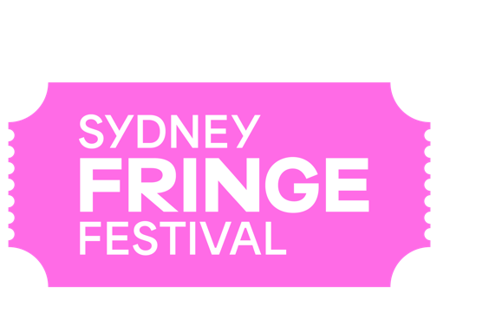
POSITION DESCRIPTION
POSITION: Publications Coordinator
LOCATION: 303 Marrickville Road, Marrickville, NSW 2204
REPORTS TO: Head of Marketing
REMUNERATION: $75,000 per annum pro rata plus super
STATUS: Fixed Term Employee (or Contractor*)
KEY AREAS: The Publications Coordinator is responsible for coordinating the production of the Sydney Fringe Festival 2024 printed guide, including gathering all content from relevant staff members, and working closely with the Festival’s designer and marketing team to ensure consistency with the Festival style guide, schedules are kept up to date and deadlines securely met.
TERM: The position is scheduled as a full-time fixed term contract based in the Sydney Fringe office from 3 June – 12 July 2024 (working Monday-Friday 9am-5pm).

Background
The Sydney Fringe Incorporated is a cultural industries organisation and advocacy group for the live arts and music sectors. The Sydney Fringe Festival was established in 2010 (www.sydneyfringe.com) and has received widespread industry support and engagement from the artistic community. In 2023, 2181 artists were featured in 400 events across all disciplines in 80 venues. Close to 100,000 people attended the event that generated over $34 million in economic impact.
Assisting artists is at the forefront of everything we do. Sydney Fringe offers a professional platform from which emerging, early career and professional artists can promote their work to new audiences. The Sydney Fringe strives to ensure that all artists have a positive Fringe experience. We believe that Sydney's independent artists are what make this city so great, and as such we are dedicated to promoting the independent sector to Sydney's mainstream audiences.

The Sydney Fringe team goes to great lengths to ensure that audiences, artists, and venues have a successful festival experience; this is the essence of what makes the Sydney Fringe so unique and is essential to the success of our festival.

Our Values
Expression; Access; Connection; Integrity; Excellence

Role Description
The Publications Coordinator’s primary responsibility is coordinating the production of the 2024 Sydney Fringe Festival printed guide. They collate, edit and proof all content including copywriting where required. They liaise with the Designer to ensure that deadlines are maintained and the print delivery date is achieved.
Key Responsibilities and Duties:
- Editing and coordination of text and images and all other content for the Festival guide within strict deadlines
- Oversee the pagination and delivery of content from relevant stakeholders and contributors to the printed Festival guide
- Proofreading and fact-checking of all content for Festival guide to the highest standards of accuracy
- Acting as a point of reference for the Marketing team on Sydney Fringe Festival copy tone of voice and adherence to the style guide
- Liaison with Sydney Fringe Festival staff and external contributors for content
- Copywriting relevant guide articles or segments and working to ensure timely delivery
- In association with the Digital and Content Manager, translation of some content for Social Media platforms as required
- In association with the Junior Marketing & Communications Manager, ensure all copy on Sydney Fringe Festival website and app is timely, accurate and engaging and consistent with printed materials
Key Skills and Knowledge
- Familiarity with graphic design and related software (e.g. Adobe suite);
- Exemplary writing skills and ability to modulate tone and messaging for different audiences;
- Meticulous attention to detail;
- Experience with Asana preferable;
- Demonstrated understanding of marketing material and its creation;
- Ability to work effectively in a fast-paced environment;
- Strong problem-solving skills, with a solutions-based approach;
- Ability to work in a small integrated team as well as the ability to work autonomously;
- Exceptional interpersonal and verbal communication skills;
- Strong planning and time management skills, with a proactive approach to managing competing tasks and priorities and work to deadlines;
- Ability to maintain effective shared folder systems, files and procedural documents;
- Enthusiasm and a positive attitude, together with an ability to be a team player;
- Values consistent with the goals and philosophy of The Sydney Fringe.

Qualifications and Previous Experience
- At least two years’ experience in materials management and/or content creation

Diversity and Opportunity
Sydney Fringe provides equal access to all applicants for positions without regard to race, colour, religion, gender, sexual orientation, gender identity, national origin, age, disability, genetic information or marital status.

How to Apply
Applications should respond to the position description, and address the selection criteria and include:
- A covering letter and current CV (no more than 3 pages)
- The names and contact details of two referees
Applications should be submitted as a PDF document with your name and the position title as the document’s name, and emailed to hq@sydneyfringe.com - please ensure that the subject of the email reads as “Publications Coordinator Application: name of applicant”.
Deadline for applications: Wednesday 8 May 2024, 5pm
Due to the high volume of expected applications, only shortlisted applicants will be contacted personally.
Should you have any further questions regarding this position please contact Zoe Davies, Business Manager, on hq@sydneyfringe.com.
Sydney Fringe is an equal opportunity employer and encourages candidates from diverse backgrounds to apply. Our organisation is committed to creating an inclusive and supportive work environment that values diversity and promotes equal opportunities.

