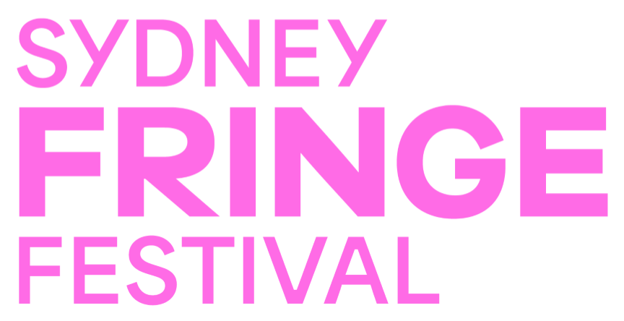  
  
**NOTE: This is a shared document. Please download or copy this form to use it for your marketing plan.**

Sydney Fringe Festival – Simple Marketing Plan Template

**Your Show Details**

* **Show Name:**
* **Genre (Comedy, Theatre, Music, etc.):**
* **Dates & Venue:**
* **Ticket Link:**

## **1. Know Your Audience**

* **Who is your ideal audience?** (e.g., comedy lovers, theatre buffs, music fans, families, young professionals)
* **Where do they hang out online and in real life?** (e.g., Instagram, Facebook, TikTok, local pubs, arts venues)
* **What kind of messaging will attract them?** (e.g., “A laugh-out-loud night for comedy lovers!”)

**Audience Persona (Optional but Helpful!):**

* Age:
* Interests:
* Where they get event info:
* Why they would love your show:

## **2. Your Marketing Goals**

* What are your top marketing goals? (Tick or add your own!)
  + Sell out opening night
  + Increase Instagram followers
  + Get media coverage
  + Build a loyal fan base for future projects
  + Other: _______

## **3. Your Key Selling Message**

* **Write a short, punchy description of your show that grabs attention:**  
   *(Example: "A hilarious, high-energy comedy that will have you in stitches—don’t miss the show critics are calling a must-see!")*
* **Call-to-Action (What do you want people to do?)**  
   *(Example: "Grab your tickets now before they sell out!")*

## **4. Marketing Tactics ️**

### **FREE (Organic) Marketing**

Where will you promote your show for free?

* Social media posts (Instagram, Facebook, TikTok)
* Fringe event listing
* Facebook event page
* Email to friends & past audiences
* Collaborations with other artists
* Community & arts forums
* Free event listing sites

**Content Plan:**

* **How often will you post?** (e.g., 3x per week)
* **What type of content will you share?** (e.g., behind-the-scenes, teaser videos, audience testimonials)

### **PAID Marketing (if budget allows)**

If you have a small budget, where will you invest?

* Facebook/Instagram Ads ($5-$10 per day)
* Google Ads
* Sponsored posts in local arts groups
* Paid event listings (TimeOut, Concrete Playground etc.)
* Flyer printing & distribution

**Budget for Paid Marketing:** $_____

## **5. Ticketing & Sales Strategy**

* **How will you drive ticket sales?** (e.g., early bird discounts, group ticket deals, last-minute promotions)
* **Any collaborations for cross-promotion?** (e.g., partnering with another artist for a ticket bundle)

## **6. Media & PR**

* **Do you have a media kit ready?** [ ] Yes [ ] No (Check out our Media Kit Guide!)
* **Who will you contact for press & reviews?** (Use our media contacts list!)
* **Any unique angles that make your show newsworthy?** (eg: “From Corporate Lawyer to Fringe Festival Clown, How This Artist Reinvented Herself Through Joy After Burnout”)

## **7. Marketing Timeline**

|  |  |
| --- | --- |
| **Date** | **Marketing Activity** |
| 4-6 Weeks Before | Announce show, create event page, start posting teasers |
| 3-4 Weeks Before | Share behind-the-scenes content, contact media |
| 2 Weeks Before | Increase social media posts, run giveaways |
| 1 Week Before | Final ticket push, reminder posts |
| Festival Week | Daily updates, audience engagement |
| Post-Show | Thank supporters, collect reviews, plan next steps |

## **8. Review & Adjust**

* What marketing efforts are working best?
* What would you change for your next show?

**Final Check: Do You Have Everything Ready?**

* Event page & ticket link
* Social media schedule
* Engaging content ready
* Media list & press release
* Clear plan for ticket sales